Polygon–Circular Open Shapes
# Source: AI Source: Provided by: [Data Path: Persons Table -> ID Column: 1, Name_En Column: Motasem Essam] -> From: [ChatGPT] on [7/25/2026]
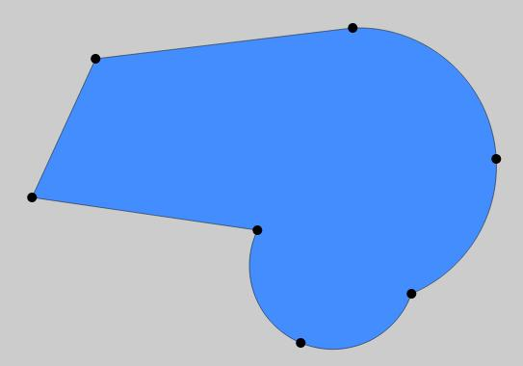
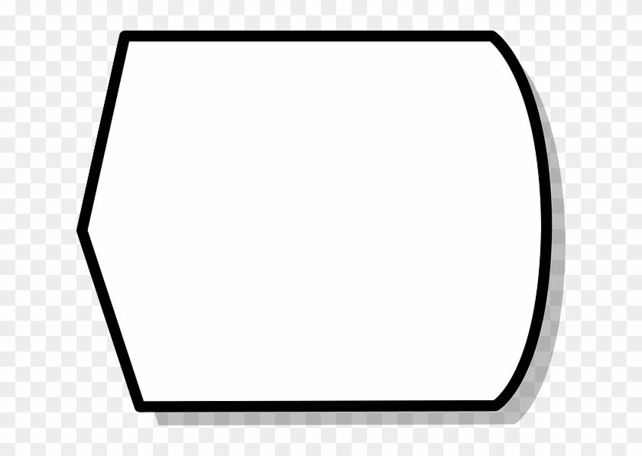

Definition
# Source: AI Source: Provided by: [Data Path: Persons Table -> ID Column: 1, Name_En Column: Motasem Essam] -> From: [ChatGPT] on [7/25/2026]
A Polygon–Circular Open Shape is an open mixed shape whose boundary or path combines straight polygonal segments with one or more circular arcs.
$$\boxed{\text{Polygon–Circular Open Shape}=\text{Straight Polygonal Segments}+\text{Circular Arc(s)}+\text{Open Boundary}}$$
Because the boundary is not completely closed, the shape does not enclose an area by itself.

Characteristics
# Source: AI Source: Provided by: [Data Path: Persons Table -> ID Column: 1, Name_En Column: Motasem Essam] -> From: [ChatGPT] on [7/25/2026]
A Polygon–Circular Open Shape:
- Is open.
- Has at least one straight-line segment.
- Has at least one circular arc.
- Combines polygonal and circular geometry.
- Has two or more endpoints depending on its construction.
- Does not form a completely closed boundary.
- May contain corners where straight segments meet.
- May contain smooth transitions where a segment meets an arc.
- Can be regular-looking or irregular.
- Can be symmetric or asymmetric.

Types of Polygon–Circular Open Shapes

1. Triangle–Circular Open Shape
# Source: AI Source: Provided by: [Data Path: Persons Table -> ID Column: 1, Name_En Column: Motasem Essam] -> From: [ChatGPT] on [7/25/2026]
An open shape combining triangular/polygonal straight segments with one or more circular arcs.
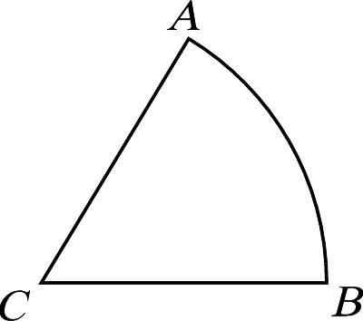
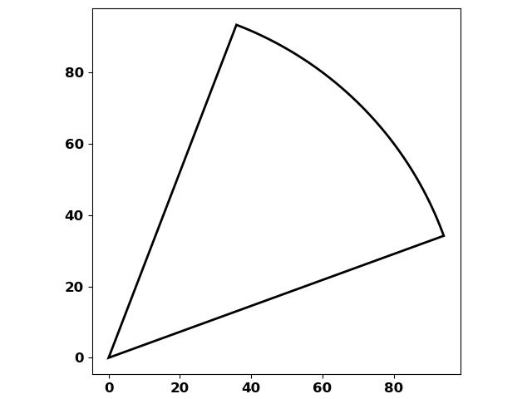
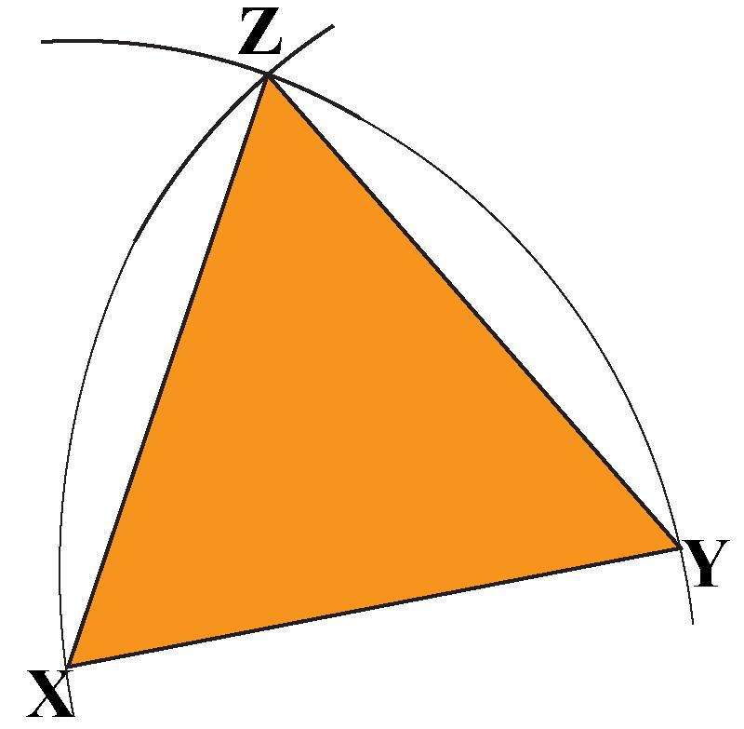

2. Rectangle–Circular Open Shape
# Source: AI Source: Provided by: [Data Path: Persons Table -> ID Column: 1, Name_En Column: Motasem Essam] -> From: [ChatGPT] on [7/25/2026]
An open path combining horizontal/vertical rectangular segments with circular arcs.
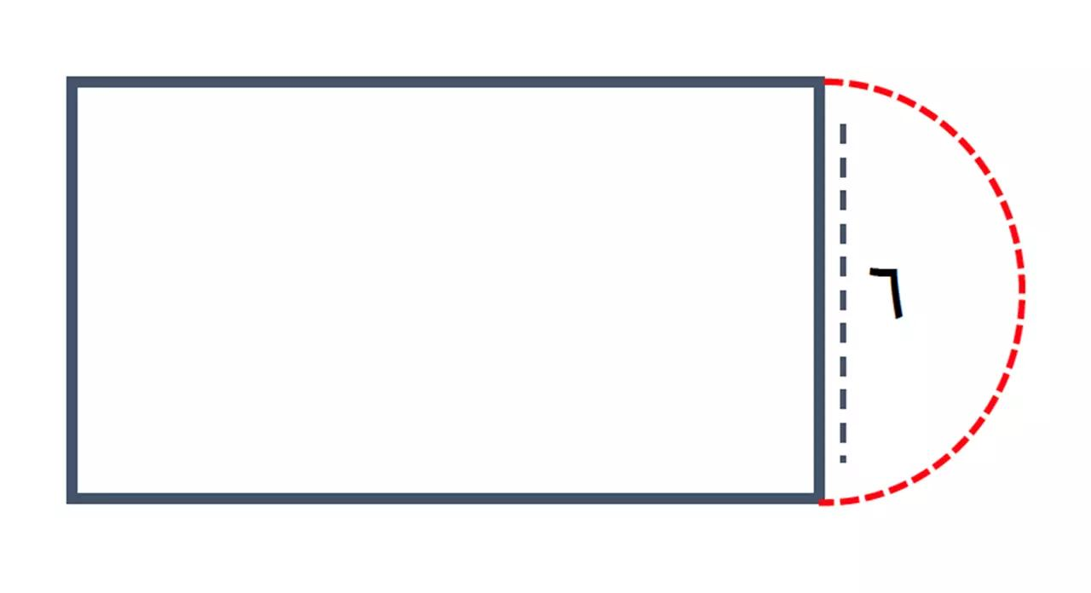
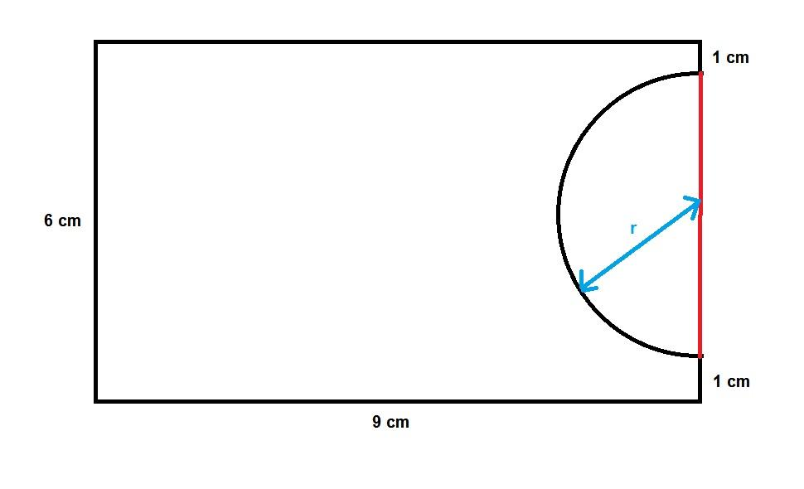
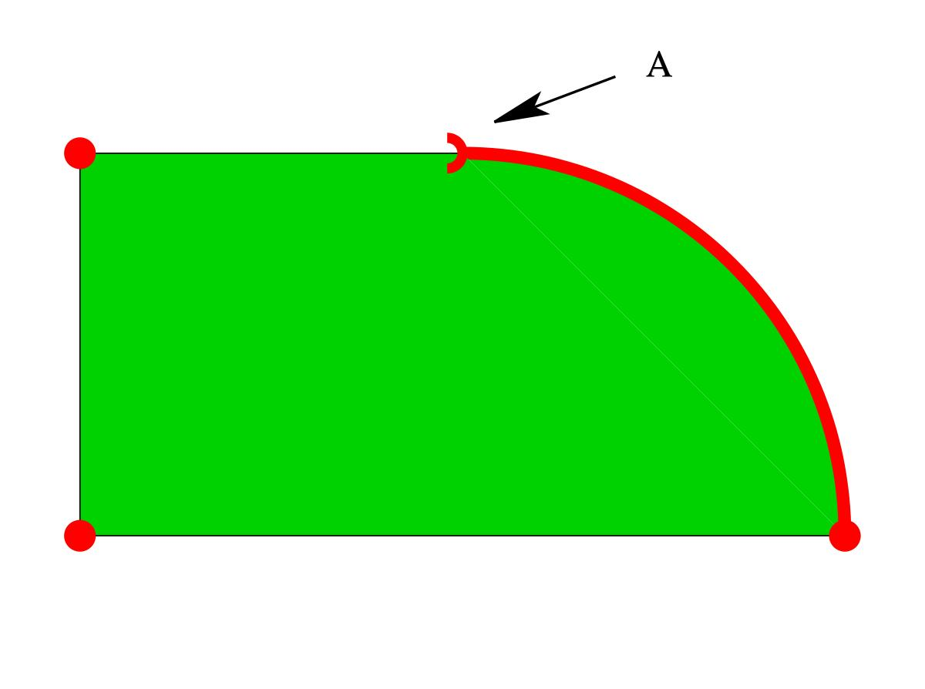

3. Polygon–Circular Arc Open Shape
# Source: AI Source: Provided by: [Data Path: Persons Table -> ID Column: 1, Name_En Column: Motasem Essam] -> From: [ChatGPT] on [7/25/2026]
A more general open shape combining several straight polygonal segments with one or more circular arcs.
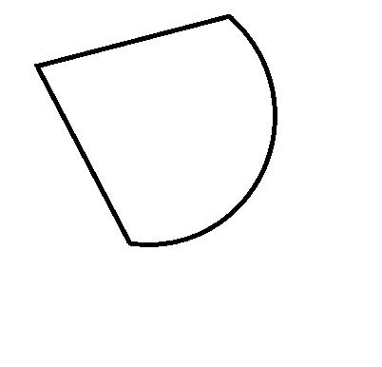
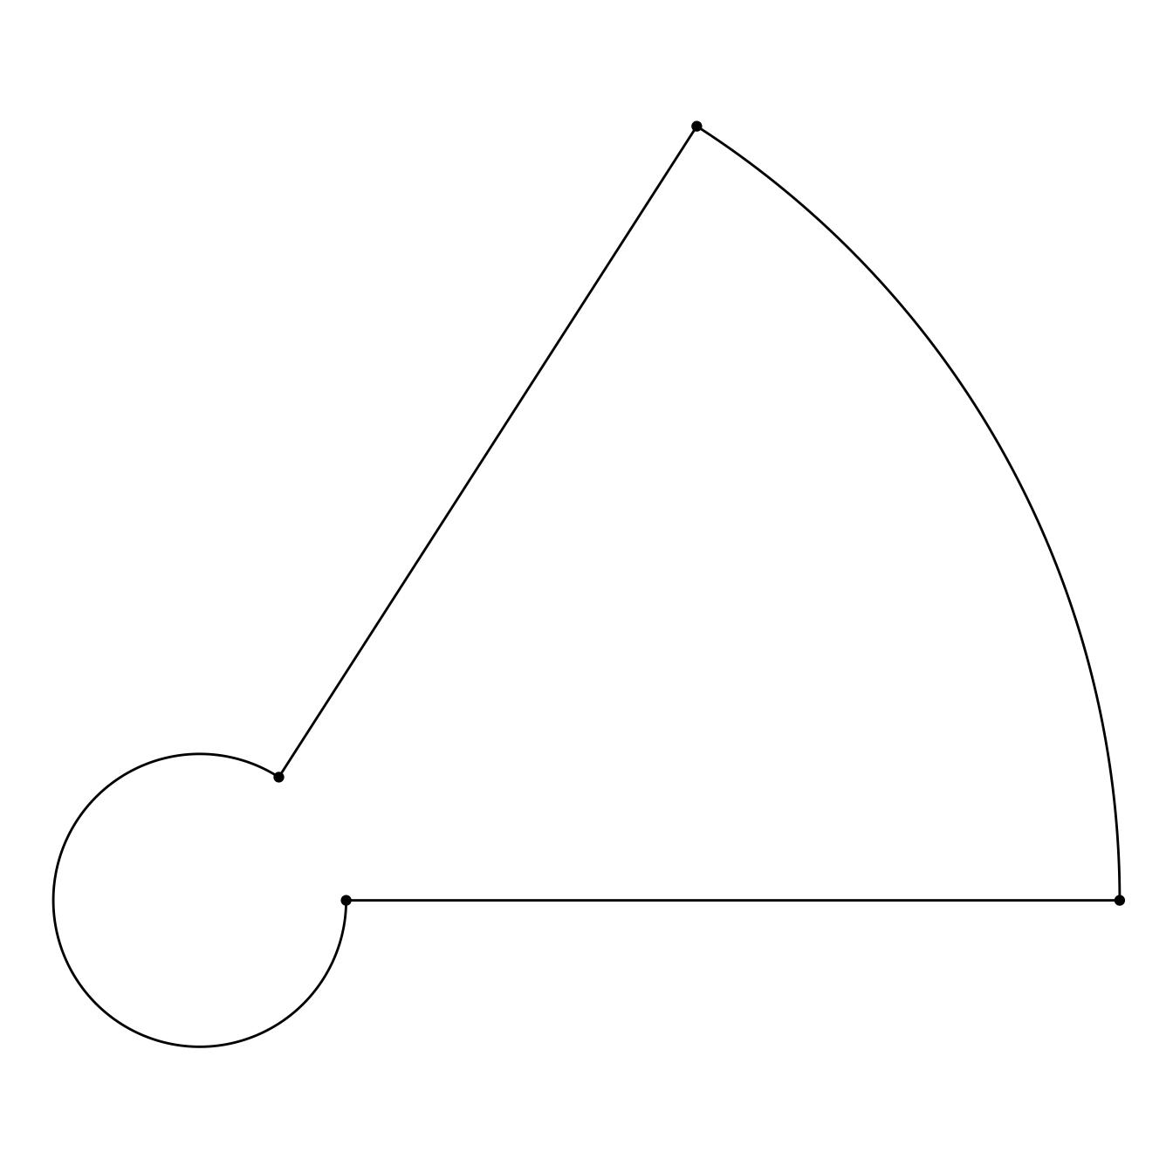
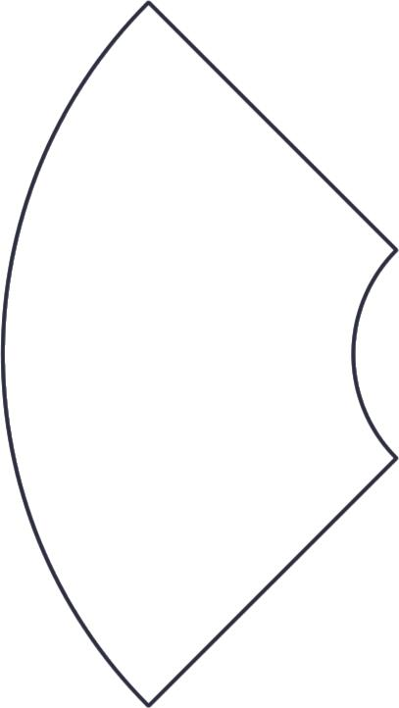

4. Single-Arc Polygonal Open Shape
# Source: AI Source: Provided by: [Data Path: Persons Table -> ID Column: 1, Name_En Column: Motasem Essam] -> From: [ChatGPT] on [7/25/2026]
A polygonal chain contains one circular arc.
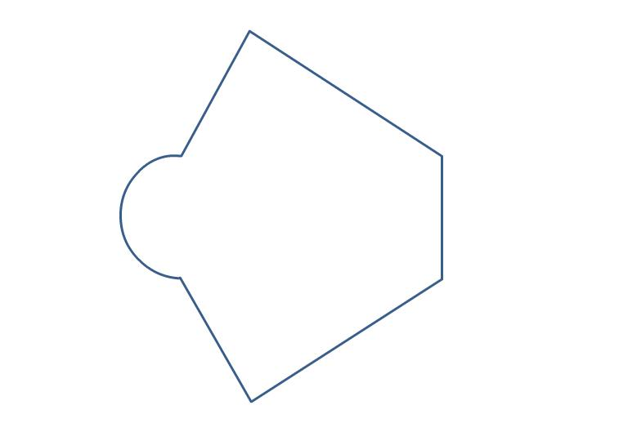
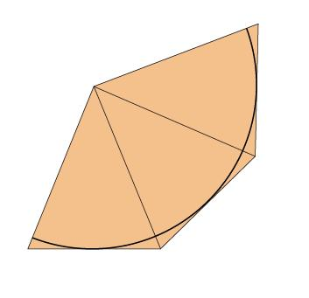
This is one of the simplest polygon–circular combinations.

5. Multi-Arc Polygonal Open Shape
# Source: AI Source: Provided by: [Data Path: Persons Table -> ID Column: 1, Name_En Column: Motasem Essam] -> From: [ChatGPT] on [7/25/2026]
A polygonal chain contains multiple circular arcs separated by straight segments.
The arcs can have equal or different radii.

6. Symmetric Polygon–Circular Open Shape
# Source: AI Source: Provided by: [Data Path: Persons Table -> ID Column: 1, Name_En Column: Motasem Essam] -> From: [ChatGPT] on [7/25/2026]
The straight segments and circular arcs are arranged with recognizable symmetry.
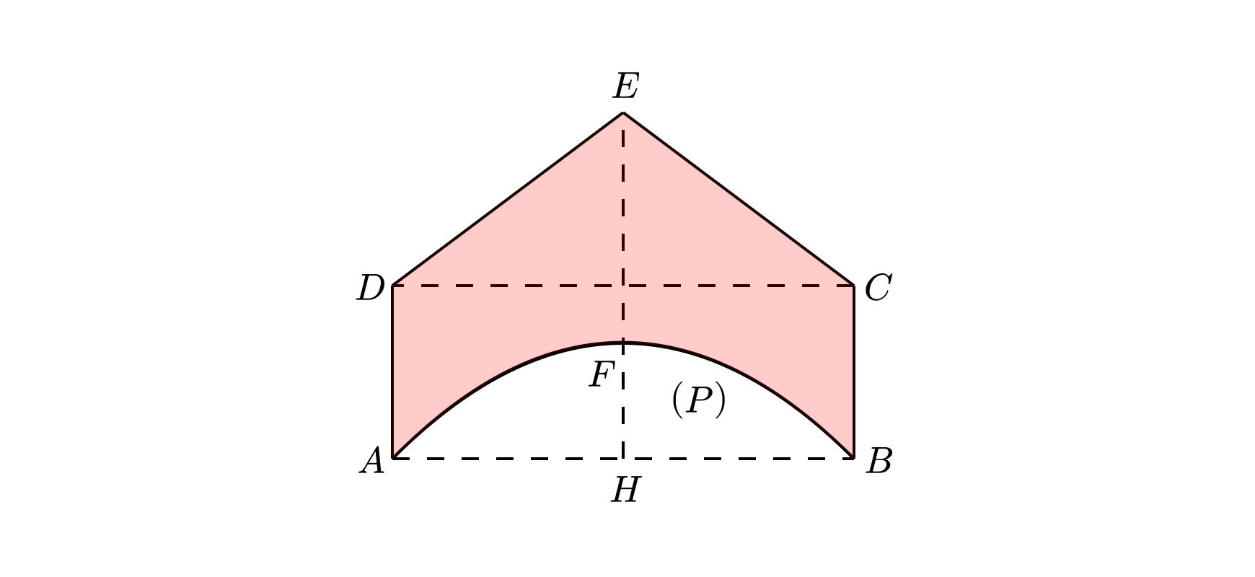
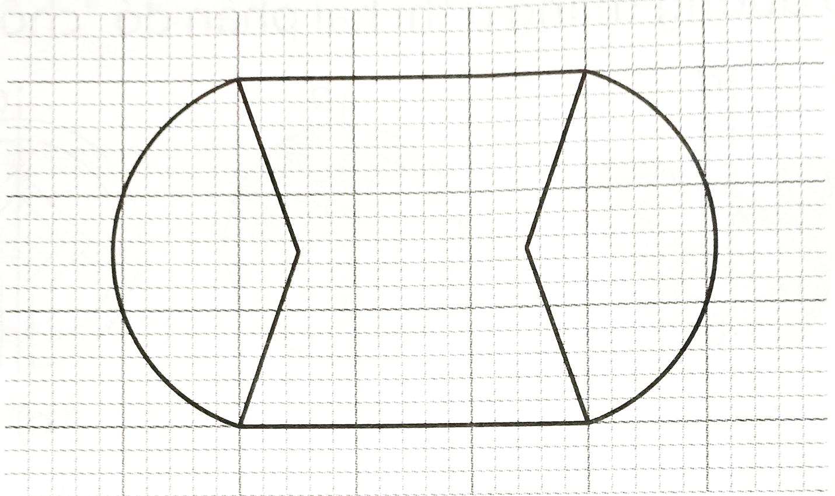
The symmetry may be about a vertical, horizontal, or other axis.

7. Asymmetric Polygon–Circular Open Shape
# Source: AI Source: Provided by: [Data Path: Persons Table -> ID Column: 1, Name_En Column: Motasem Essam] -> From: [ChatGPT] on [7/25/2026]
The straight segments and circular arcs have unequal lengths, positions, or radii.
This is especially useful for irregular mixed-shape classification.

8. Tangential Polygon–Circular Open Shape
# Source: AI Source: Provided by: [Data Path: Persons Table -> ID Column: 1, Name_En Column: Motasem Essam] -> From: [ChatGPT] on [7/25/2026]
A straight segment connects smoothly to a circular arc at a tangent point.
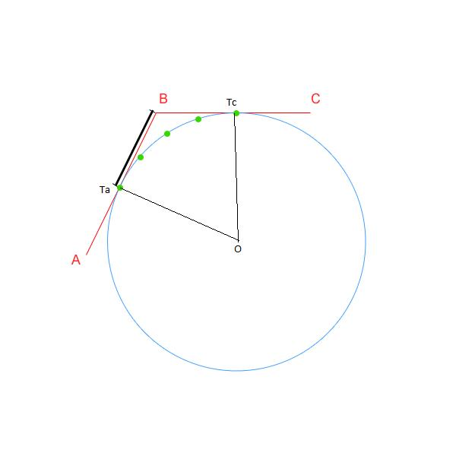
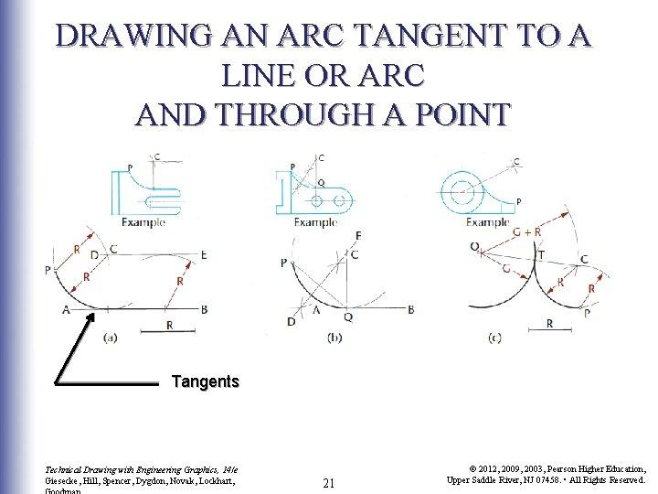
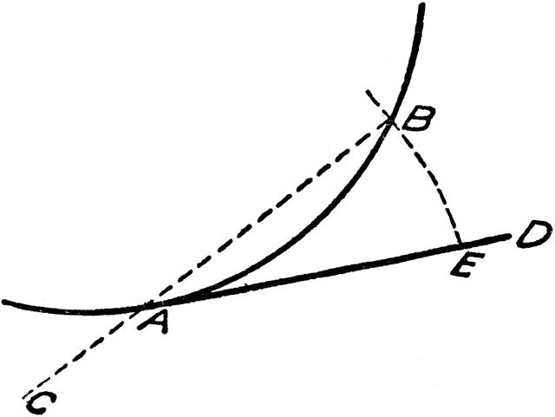
At the joining point, the straight segment and arc can share the same tangent direction.

9. Cornered Polygon–Circular Open Shape
# Source: AI Source: Provided by: [Data Path: Persons Table -> ID Column: 1, Name_En Column: Motasem Essam] -> From: [ChatGPT] on [7/25/2026]
A circular arc meets straight segments at visible corners.
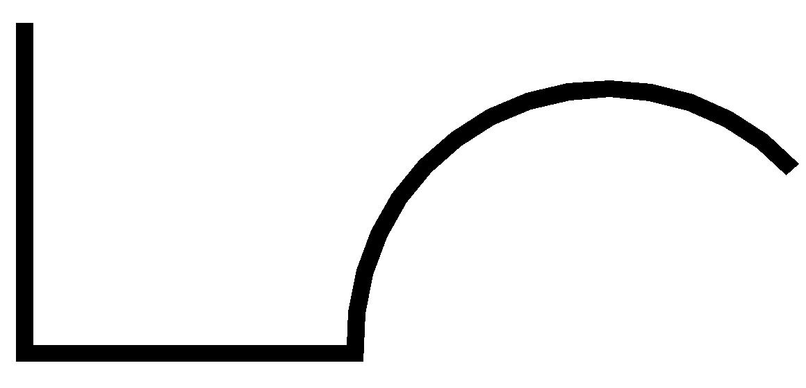
Unlike a tangential connection, the direction changes abruptly at the junction.

10. Wavy Polygon–Circular Open Shape
# Source: AI Source: Provided by: [Data Path: Persons Table -> ID Column: 1, Name_En Column: Motasem Essam] -> From: [ChatGPT] on [7/25/2026]
The open shape contains multiple straight segments and circular arcs arranged in a wave-like pattern.
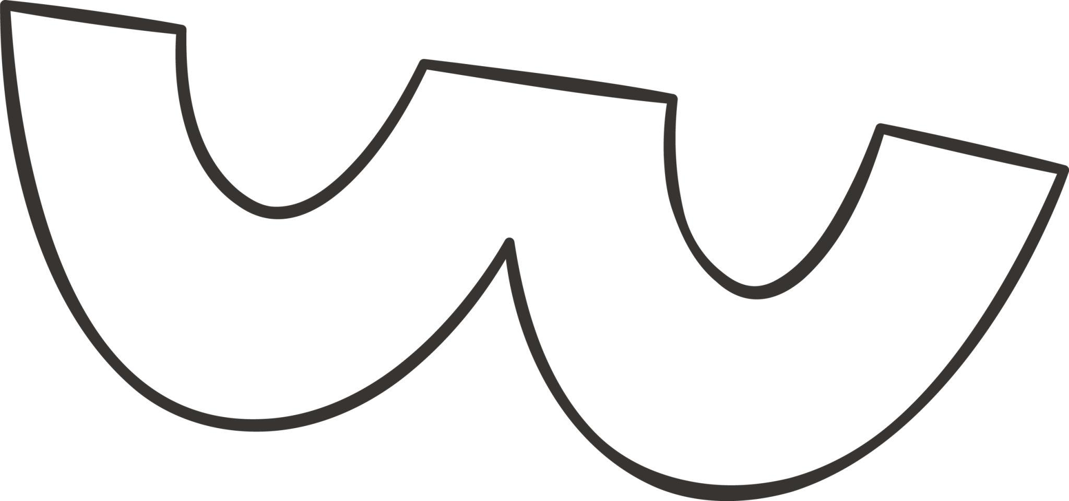
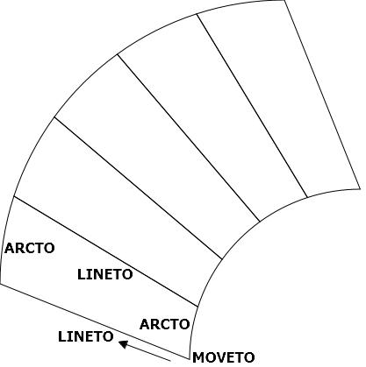

11. Step-Like Polygon–Circular Open Shape
The straight portions create a step-like path while circular arcs are incorporated into some sections.
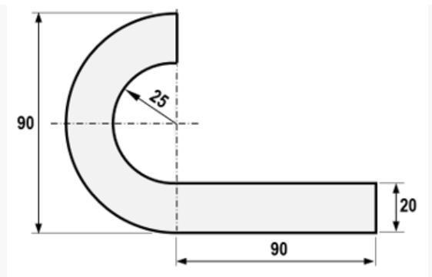
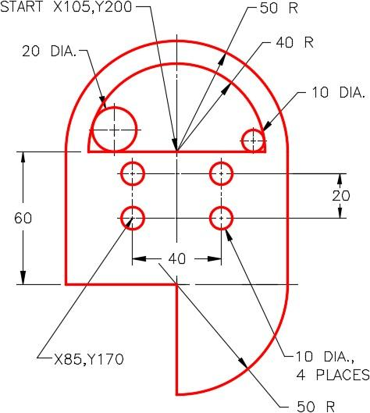
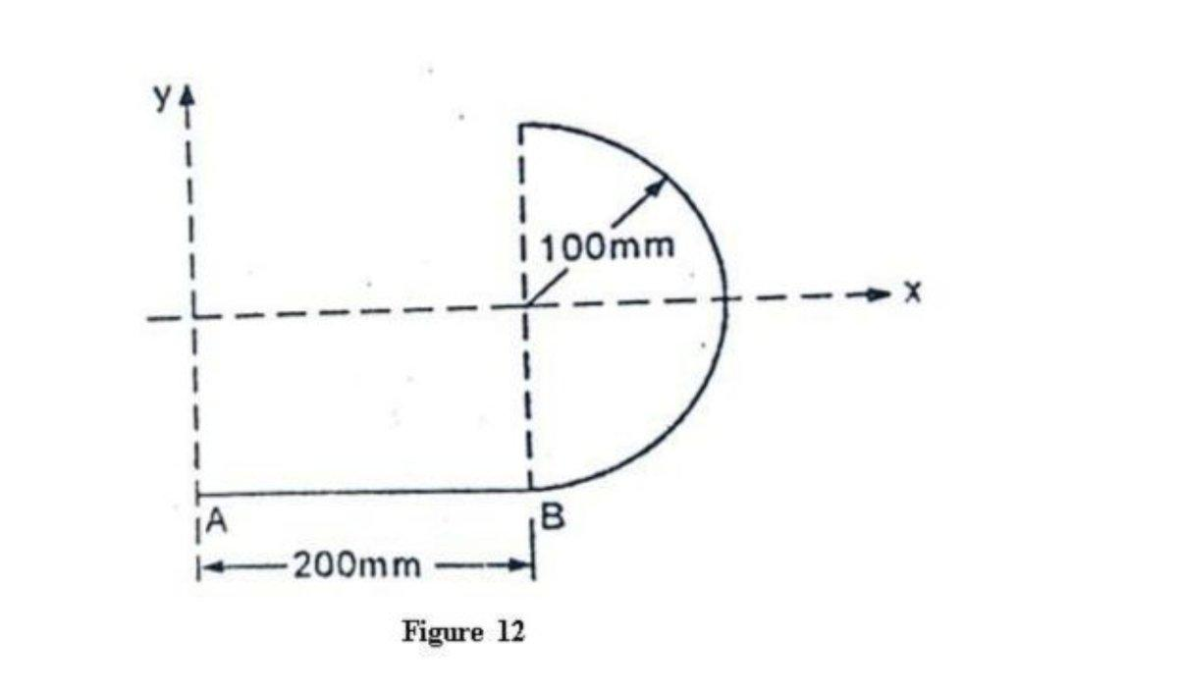

12. Freeform Polygon–Circular Open Shape
A freely designed open shape combining polygonal segments and circular arcs without a fixed standard configuration.

Polygon–Circular vs. Pure Polygonal Open Shapes
# Source: AI Source: Provided by: [Data Path: Persons Table -> ID Column: 1, Name_En Column: Motasem Essam] -> From: [ChatGPT] on [7/25/2026]
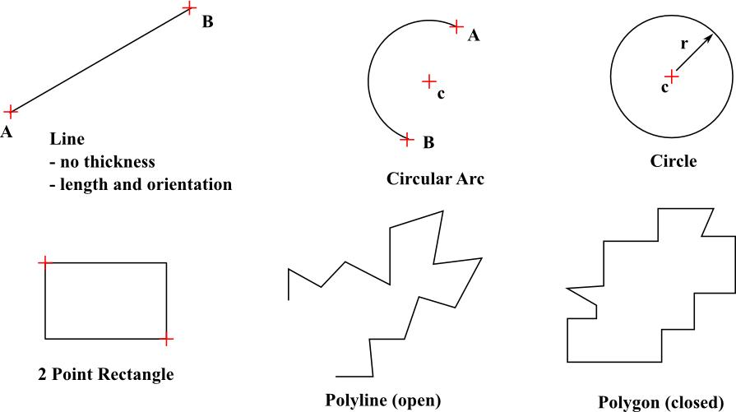
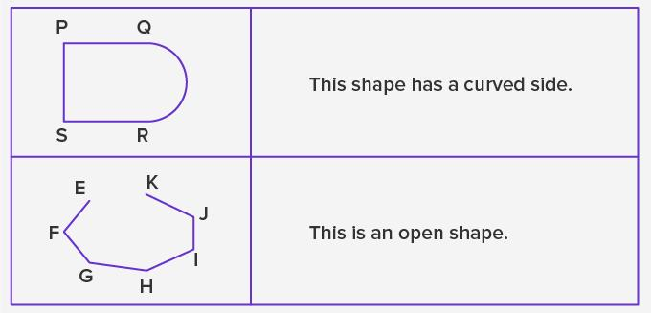
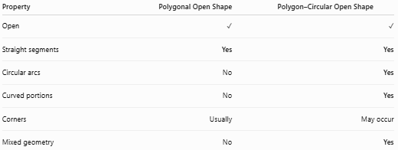
Property | Polygonal Open Shape | Polygon–Circular Open Shape
Open | ✓ | ✓
Straight segments | Yes | Yes
Circular arcs | No | Yes
Curved portions | No | Yes
Corners | Usually | May occur
Mixed geometry | No | Yes
Main distinction
$$\boxed{\text{Polygonal Open Shape}=\text{Straight Segments Only}}$$
while:
$$\boxed{\text{Polygon–Circular Open Shape}=\text{Straight Segments + Circular Arcs}}$$

Polygon–Circular vs. Open Curved Shapes
# Source: AI Source: Provided by: [Data Path: Persons Table -> ID Column: 1, Name_En Column: Motasem Essam] -> From: [ChatGPT] on [7/25/2026]
A circular arc alone is an open curved shape.
When straight polygonal segments are added, it becomes an open mixed shape.
$$\boxed{\text{Circular Arc}→\text{Open Curved Shape}} \\ \boxed{\text{Polygonal Segments + Circular Arc}→\text{Open Mixed Shape}}$$

Key Points
# Source: AI Source: Provided by: [Data Path: Persons Table -> ID Column: 1, Name_En Column: Motasem Essam] -> From: [ChatGPT] on [7/25/2026]
A Polygon–Circular Open Shape is:
$$\boxed{\text{Open}+\text{Polygonal}+\text{Circular}}$$
It:
- Has straight polygonal segments.
- Has at least one circular arc.
- Is not completely closed.
- Does not enclose an area by itself.
- May have corners or smooth tangent connections.
- May be regular-looking or irregular.
- May be symmetric or asymmetric.
- Can contain one or multiple circular arcs.

Conclusion
# Source: AI Source: Provided by: [Data Path: Persons Table -> ID Column: 1, Name_En Column: Motasem Essam] -> From: [ChatGPT] on [7/25/2026]
Polygon–Circular Open Shapes are mixed open shapes formed by combining straight polygonal segments with circular arcs. Their defining feature is the coexistence of linear and circular geometry within an open boundary. They can be further classified by the number of arcs, symmetry, type of connection, and overall arrangement.

